|  |
| --- |
| Sense Innovations |
| EssEv APP quick start guide |
| V1.0 |

|  |
| --- |
| Bradley Wang  2019-10-31 |

# Install the APP

1. Click the EssEv_xxxx.apk to install the EssEv APP.
2. Enable the “storage” and the “location” permission during the installation.
3. Finish the installation and start the APP.

# Scan the EssEv

Open the EssEv APP, the app will scan the BLE device automatically. You can find the device “EssEvSoco” in the list.

If there is not any device in the list. Please check whether you have open the Bluetooth function or enable the “location” permission for this app.

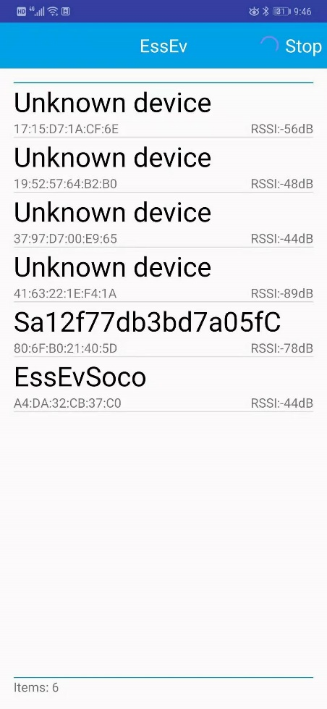

# Connect the EssEv

1. Click the device which you want to connect.

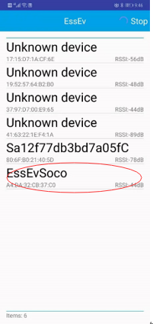

1. Enter the device page and click the “Connect” button in the upper right corner.

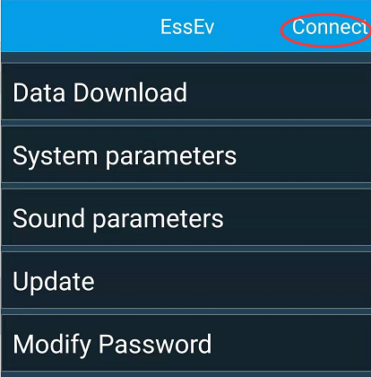

1. Check the connecting device name and click “OK”.

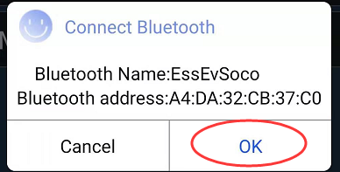

1. Input the password. The origin password is “000000”.

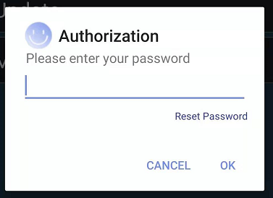

1. Connection will be established after password authorization.

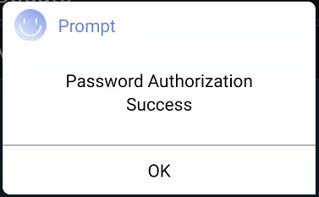

# Download engine sound

1. Click the “Data Download” button enter the sound download function.

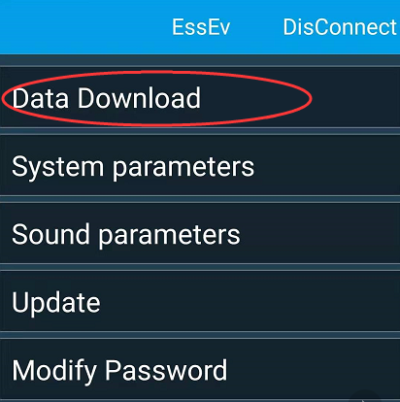

1. The EssEv can install 4 engine sounds. In the “Select vehicle” drop down box, select the sound installation position. And then click the green download icon which is at the right of the sound you want to install.

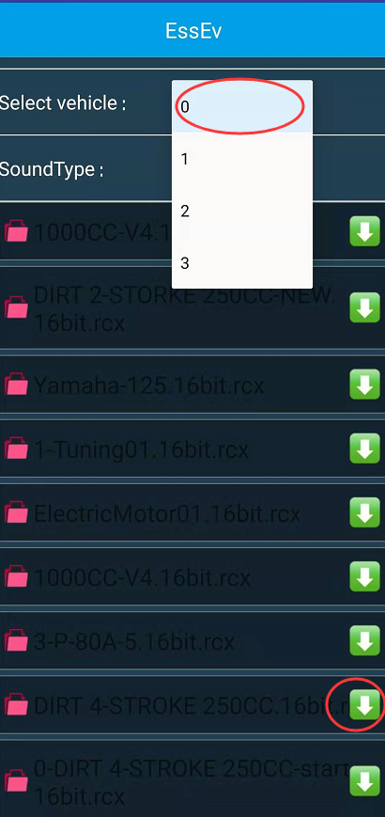

# Parameter setting

Click the “System parameters” item to enter the parameter setting page.

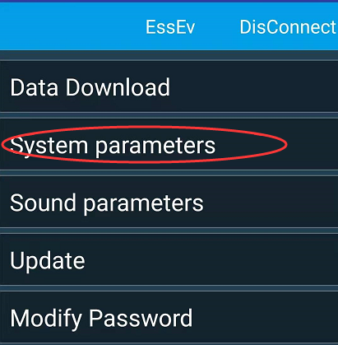

The parameter setting page is as follow:

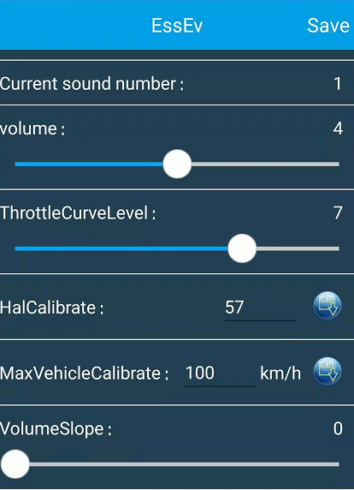

Current sound number: Mention which engine sound is playing now.

Volume: Set the volume. 0 is mute.

ThrottleCurveLevel: Set the corresponding relation between the speed of the engine sound and the speed of the motorcycle when the motorcycle is in ready mode. When the value is 0, it is linear. As the value increasing, the engine sound will change more when the motorcycle in low speed and change less when the motorcycle in high speed. The default value is 0.

VolumeSlope: default value is 0. As the value increasing, the volume at low speed will decrease and the volume at high speed will increase.